**CSCE 5320 Scientific Data Visualization**

**Creating Visualizations in Tableau**

Tutorial 1

Download the excel file named “Superstore**”**. Open Tableau and then connect to the Excel data, the data source page shows the sheets or tables in your data.

Here, in the given dataset you have one sheet or table named “Orders”.

To add a new worksheet, click on sheet1, a new worksheet will be added and then rename it as worksheet1 by giving right click on sheet1 and select rename, then change the name to worksheet1.

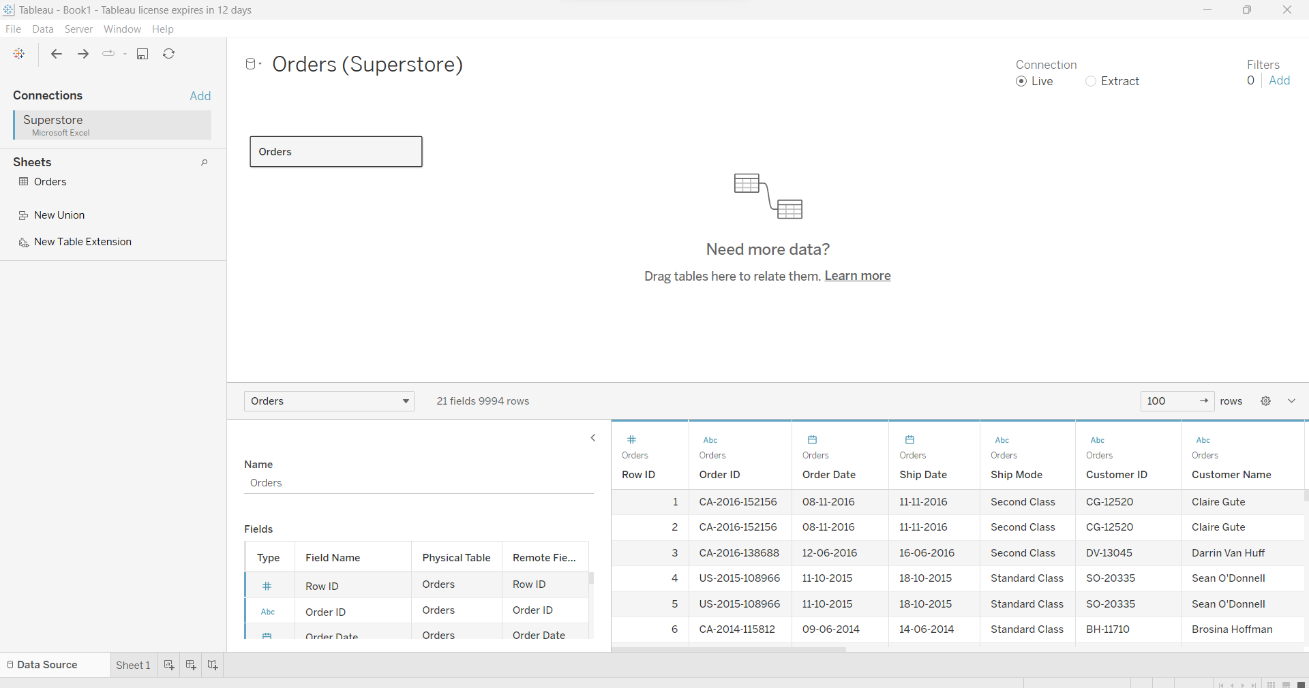

We need to select attributes for rows and columns. This can be done by just dragging and dropping the fields present to the left side of the sheet as shown below

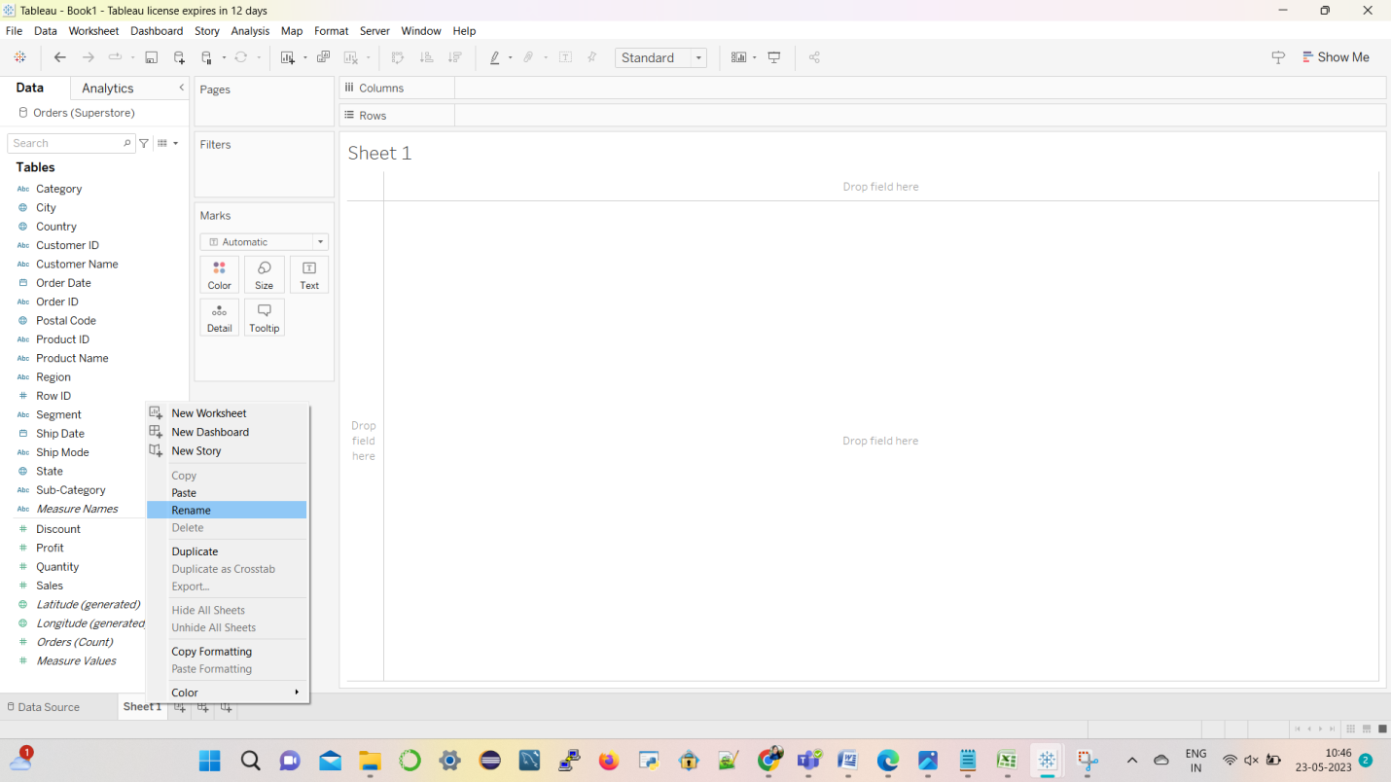

Let’s put Sub-Category from the left side to the rows.

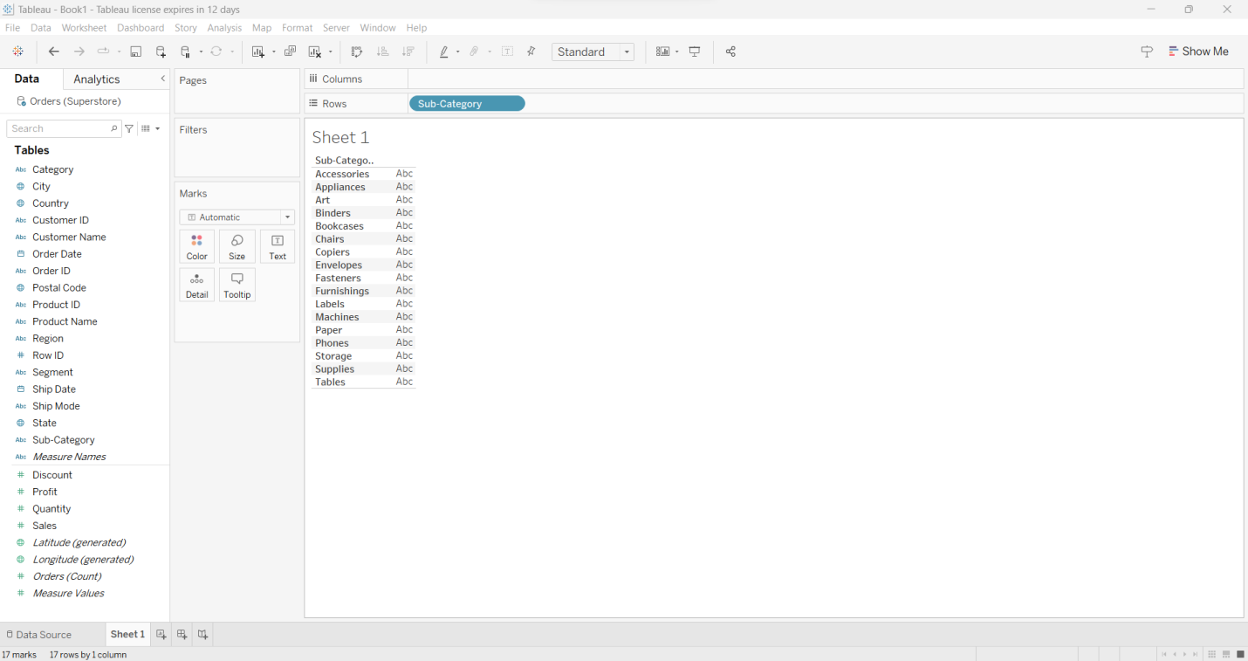

Above is the graph that shows different Subcategories(Accessories, Appliances, Art, Chairs, Storage etc.)

**Step 1:-** Add Sub-category to rows and Quantity to the columns from the left side.

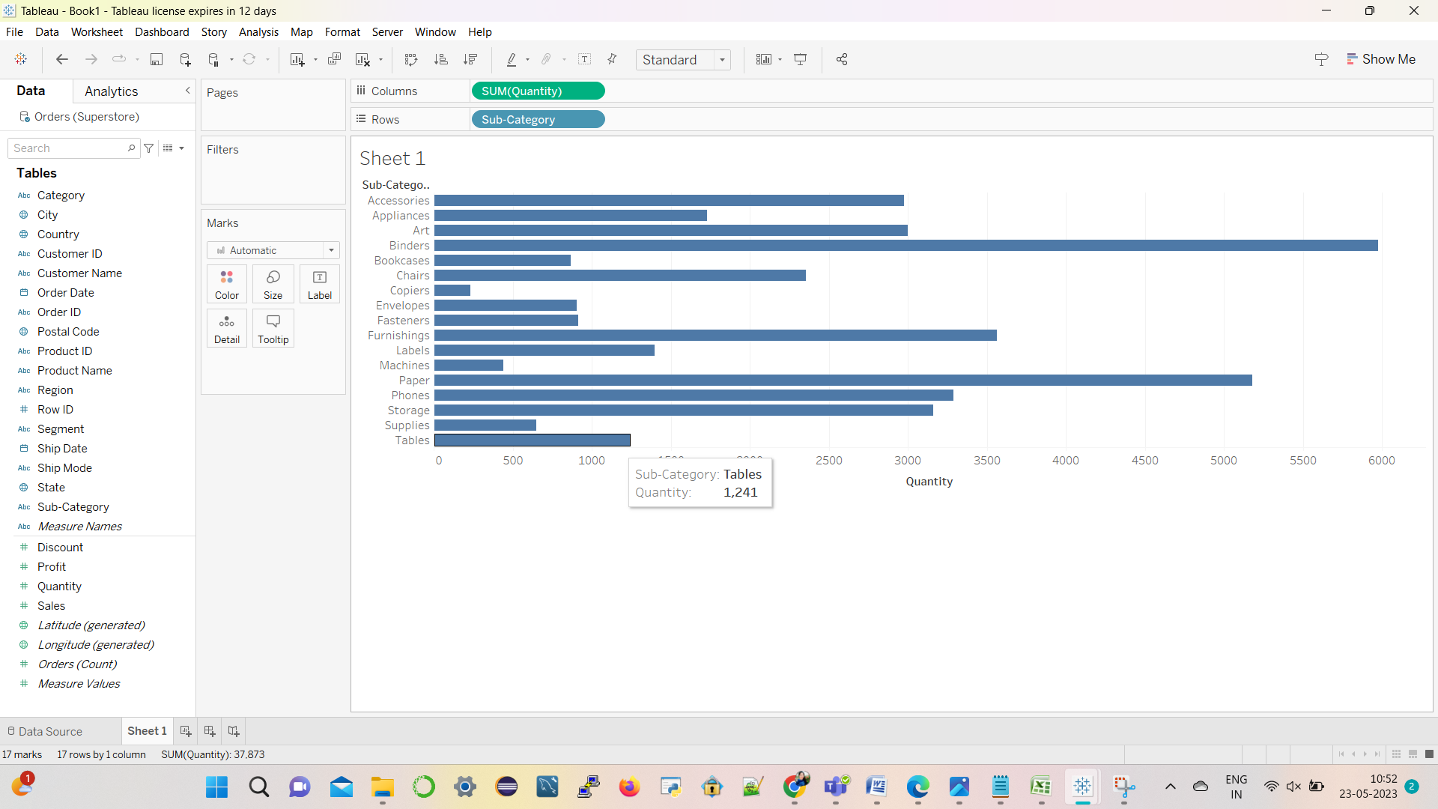

In the above data we used Horizontal bar graph visualization:

In general, horizontal bar graph visualizes categorical data which are usually represented in rectangle bars. The length of the bar is value it consists.

**Types of Variables used in the graph:**

**Quantity** is a quantitative data, it has numerical values.

**Sub - Category** is a categorical data because it is classified as type of items (i.e., Binders, Appliances, Machines etc.).

***Observation****:*

* In the above graph, as per task we used Sub - Category in rows and Quantity in columns so the tableau used Horizontal bar graph and we can use some the graphs but also this data suites Horizontal bar graph visualization.
* In above graph we can observe Binders subcategory has highest quantity and copiers has least quantity.
* When we place cursor on the graph, we can see that Tables Sub-category have quantity around 1,241.

Click on show me to select various types of visualizations. There will be different visualizations like pie chart, Stacked bars, side by side circles based on the given attributes to the rows and columns.

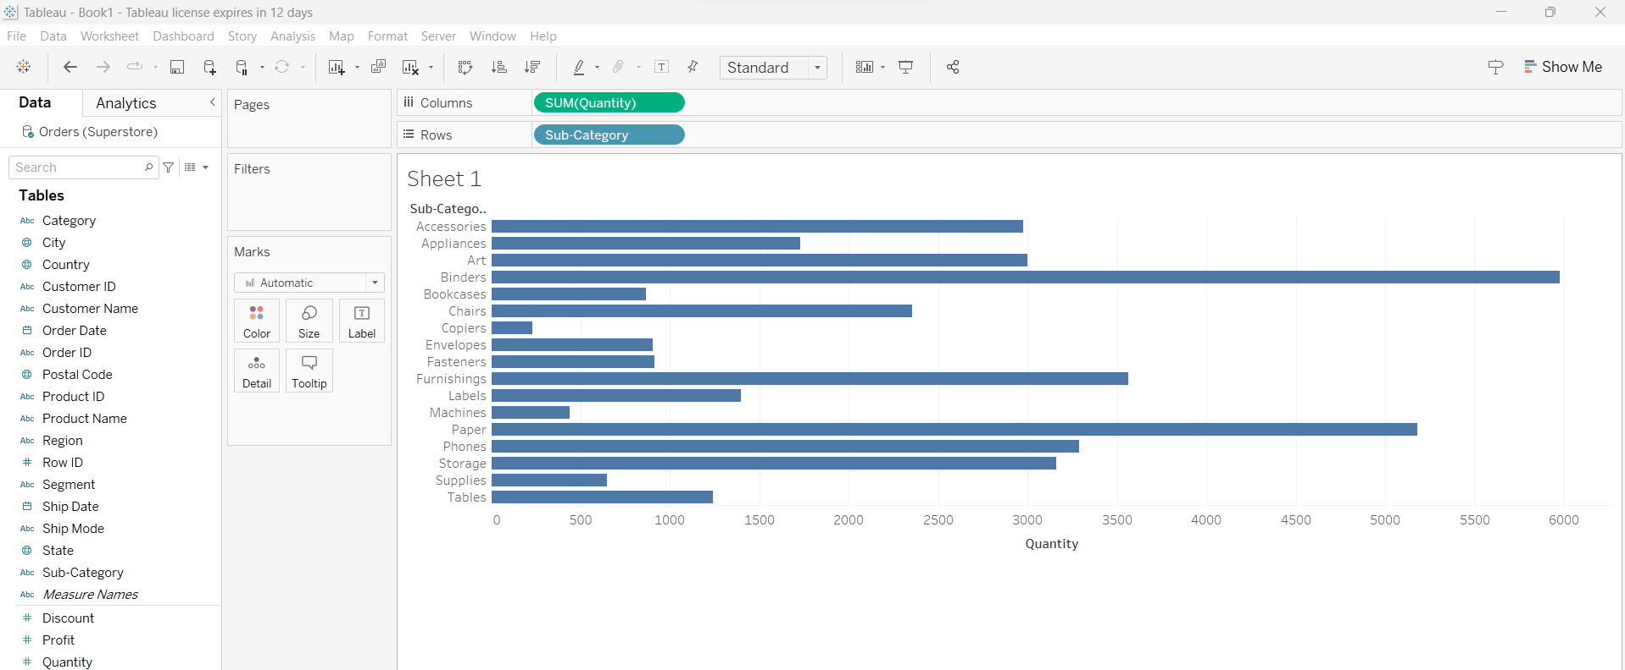

**Step 2:-** Select the Stacked Bar Chart from the menu and record the analysis.

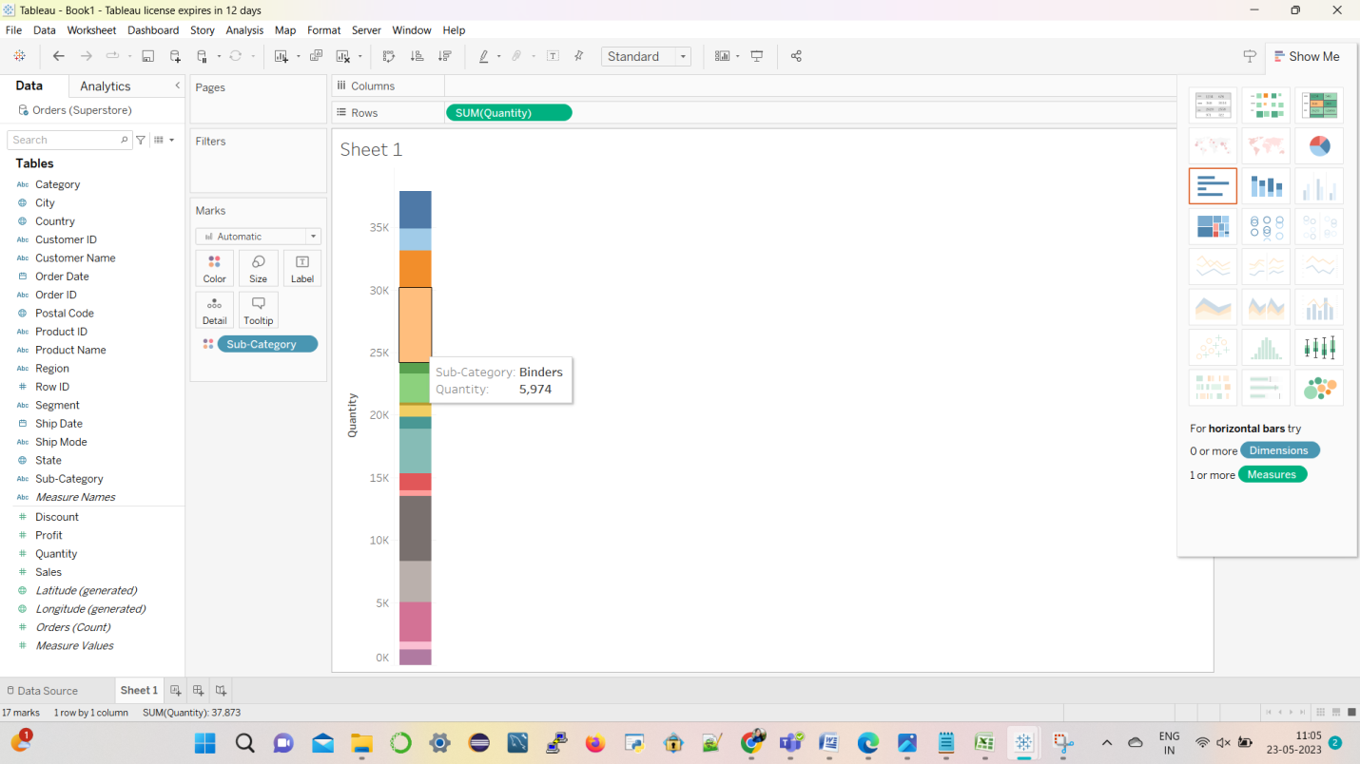

Above, we can see a stacked bar chart. Here, each sub category is differentiated with different colors and Quantity is in rows shelf.

When we place cursor on the screen, it shows quantity of Binders is around 5,974.

**Step 3:-** Now, try using the Heat maps visualization and note the changes from the previous visualization.

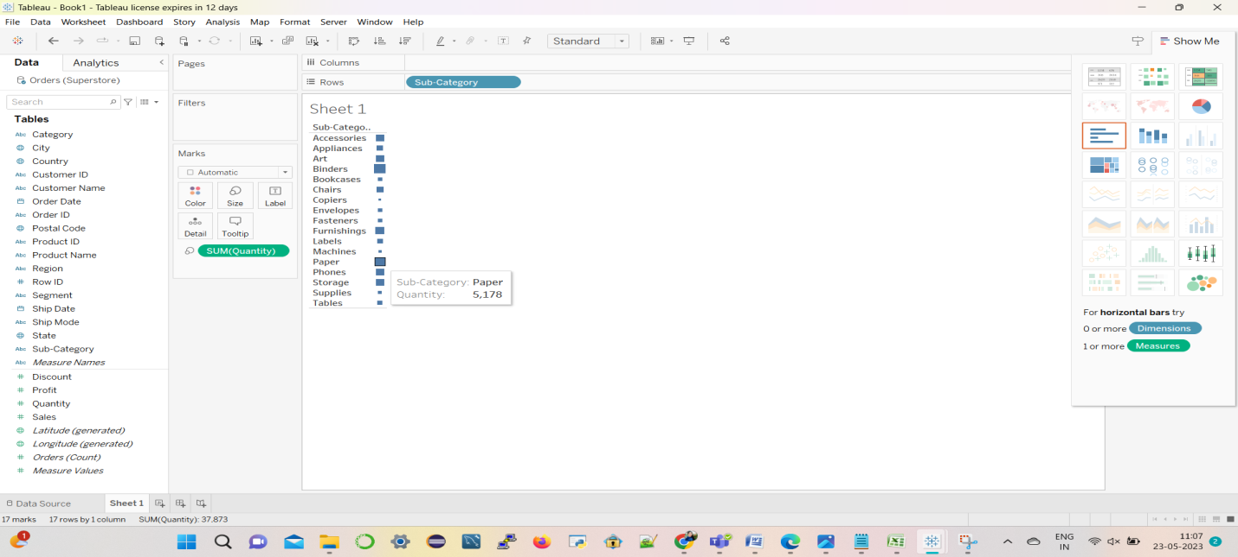

Above is the heat maps visualization. Here, we can see that according to the value of quantity the size of square boxes is getting varied.

When we place cursor on the respective square boxes, we can see the quantity of Paper is 5,178. It is represented by square box which is large compared to art, machines sub category.

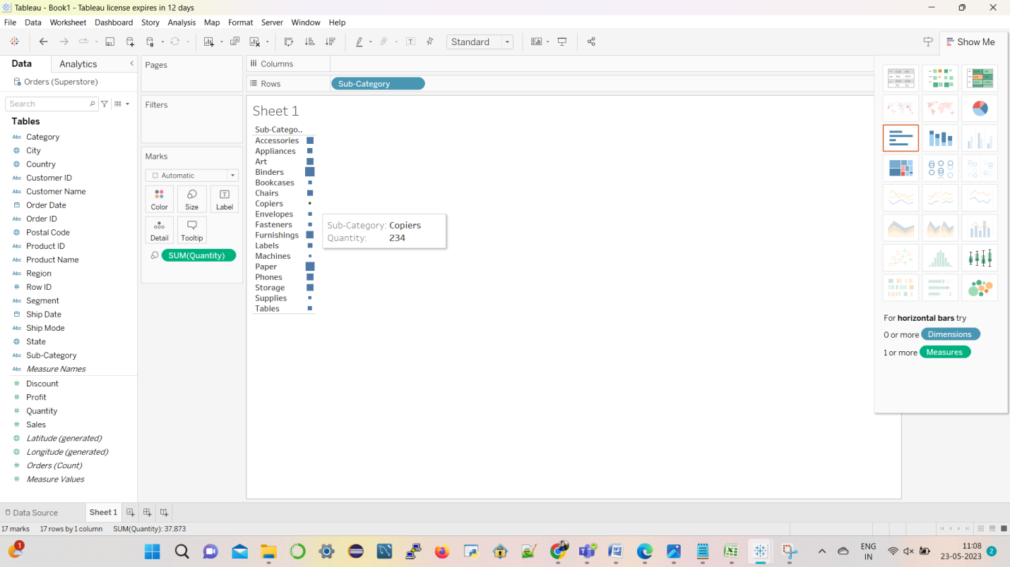

Here, we can see the quantity of copiers is 234. It is represented by a very small square box, as the quantity is very less compared to quantity of other sub category.

**Step 4:-** Adding Region to Filter

Drag the region from the left side to filters and select the region. Here, we have selected the west region by clicking the check box west. After selecting it click on apply and then click ok.

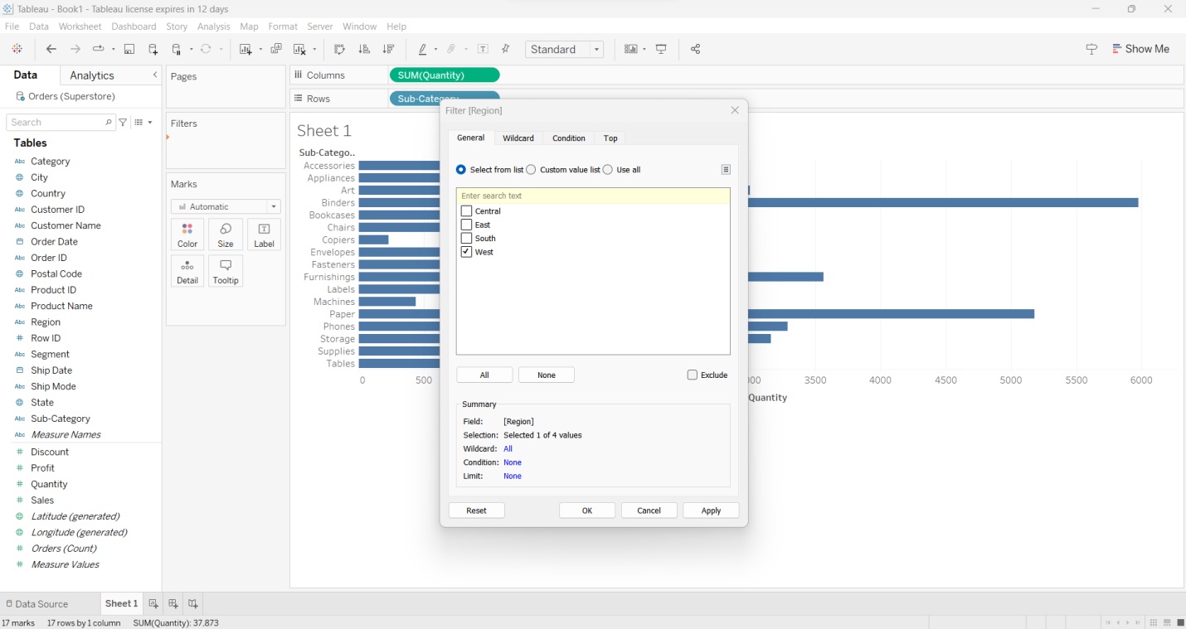

**West Region:** Here, I have selected the Western region. We can observe the change in the graphs when we have selected different regions.

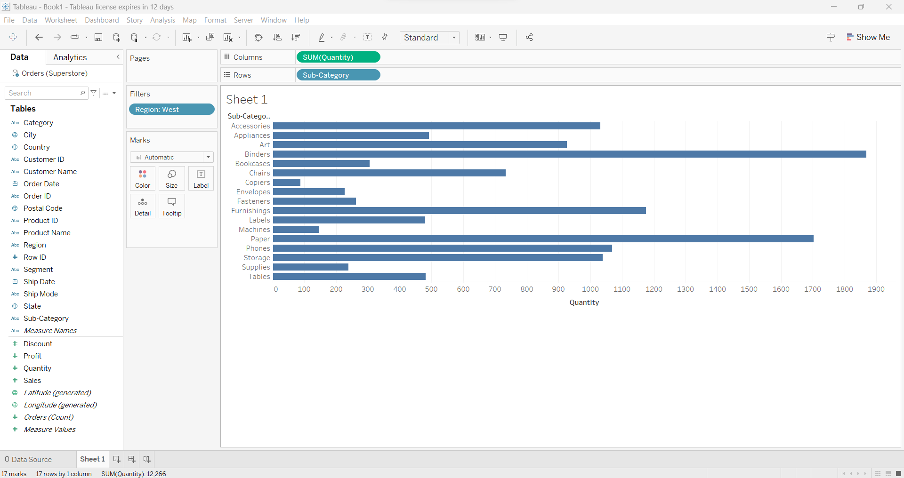

***Observation:***

* After adding region on to the filter visualizing data becomes easier but before adding filter the graph shows the data irrespective to the region.
* But after addition of the filter, we can easily visualization the data as per region with all different Sub Categories.
* For instance, in the above visualization, we selected West in the region so, it displays Quantity of all the sub categories in that particular region.

**Step 5:-** Click on region, and then click on show filter .It displays the region on right side of the screen. Then you can select the required region.

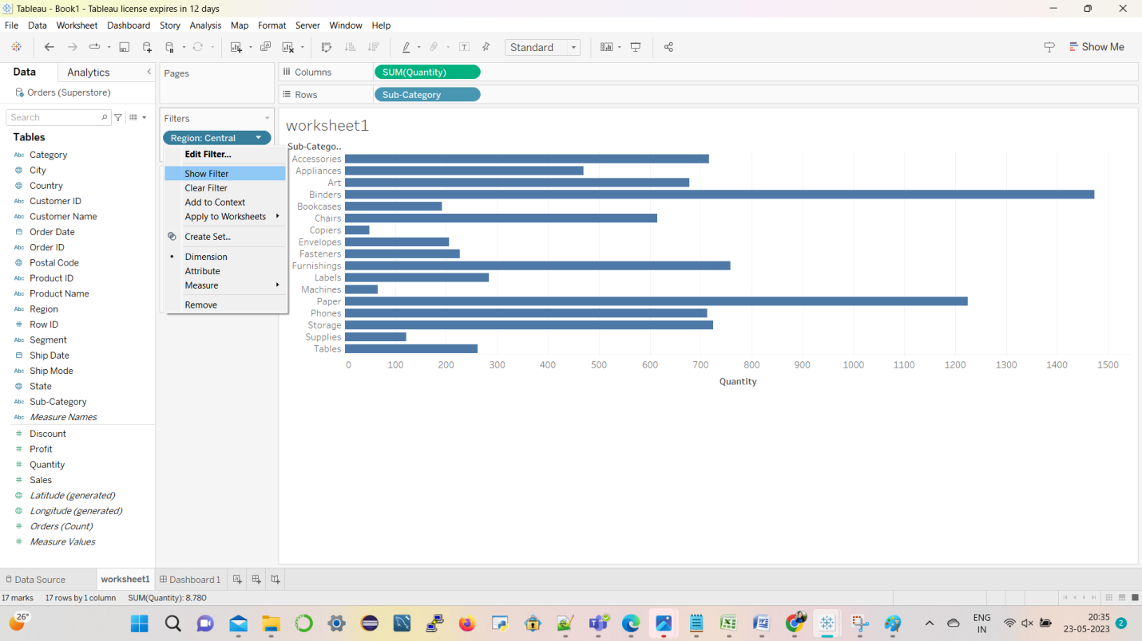

**Central Region:**

Here, I have selected the central region. We can observe the change in the graphs when we have selected different regions.

For example, Tables have quantity in between “400-500” and in central region it is between “200-300”.

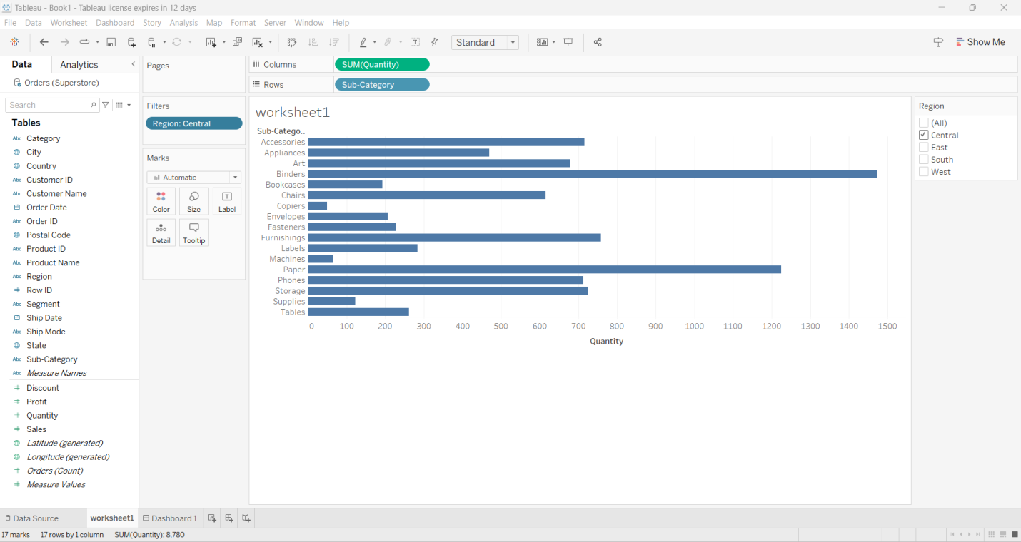

**Question 1( 20%)**

Follow tutorial 1 and complete the below task for the given attributes.

1) Add a new sheet and click on “Ship Mode” and drop it in the rows and click on “Profit” and drop it on columns. Add Region to filters and select “South”.

2) Click on show me and Visualize at least 2 Charts with the above attributes and note the Analysis.

3) Which region has the maximum Profit of the first class ship mode and how much?

4) Identify the ship mode with the lowest profit and assess whether it is performing poorly in the other regions.

5) Analyze the visualizations and explain your understanding of the task.

**Tutorial 2**

**Step 1:- Create a Dashboard**

Click on Dashboard1, to create a new dashboard. After creating a new dashboard, drag the worksheet 1 from the left side and drop it on the dashboard screen.

Here, we can select the different regions and we can observe changes in the quantity of sub-category’s.

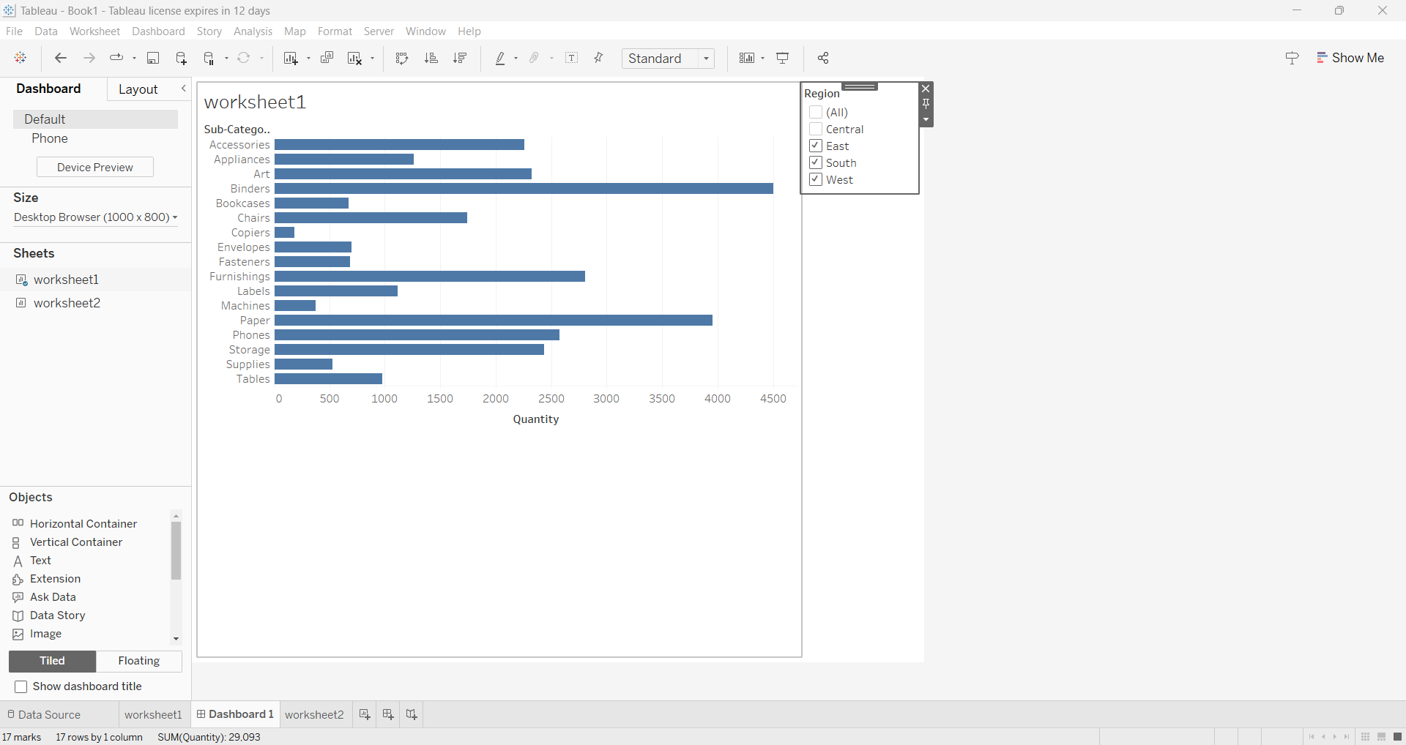

**Step 2:-** Create Worksheet 2

As Shown above (arrow mark pointing) click on new worksheet.

Rename the worksheet as worksheet 2 and Drag Quantity from the left side and put it to the rows shelf. Then drag Order Date to column shelf.

Click ”+” on the Year to get the Quarter(Order Date)

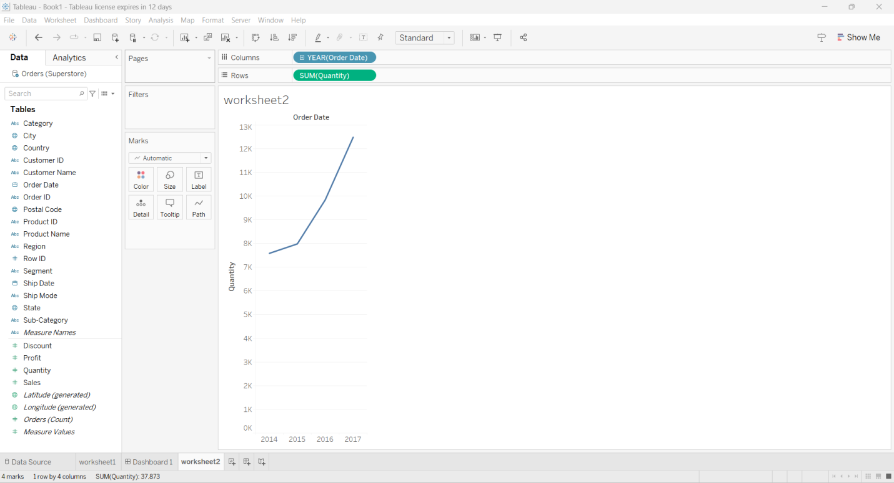

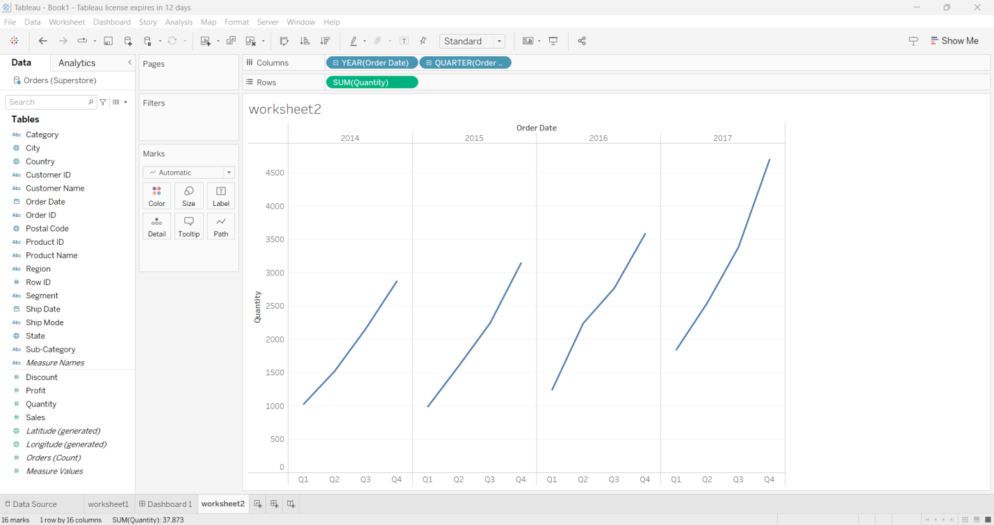

The above data used Lines graph visualization

Tableau is well-known for its ability to handle large amounts of data quickly and produce the necessary data visualization output. A line graph, often known as a line chart, is a graph that depicts the change in value over time.

**Types of Variables used in the graph**

**Quantity** is a quantitative data since it has numerical values.

**Order Date** is a categorical data because it can be classified as years and also expanded in quarterly too.

**Step 3**:- Again Click on the Region from the left side and drop in the filter. Then choose one of the regions and click apply and click ok.

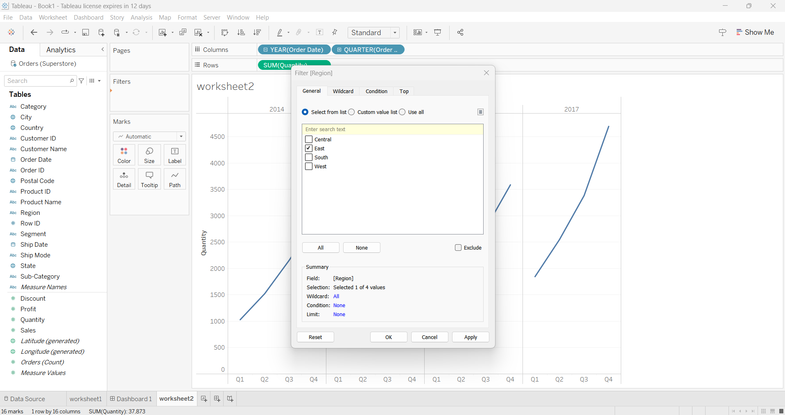

**Step 4**:- By clicking on region, and then click on show filter .It displays the different regions on right side of the screen. Then you can select the required region.

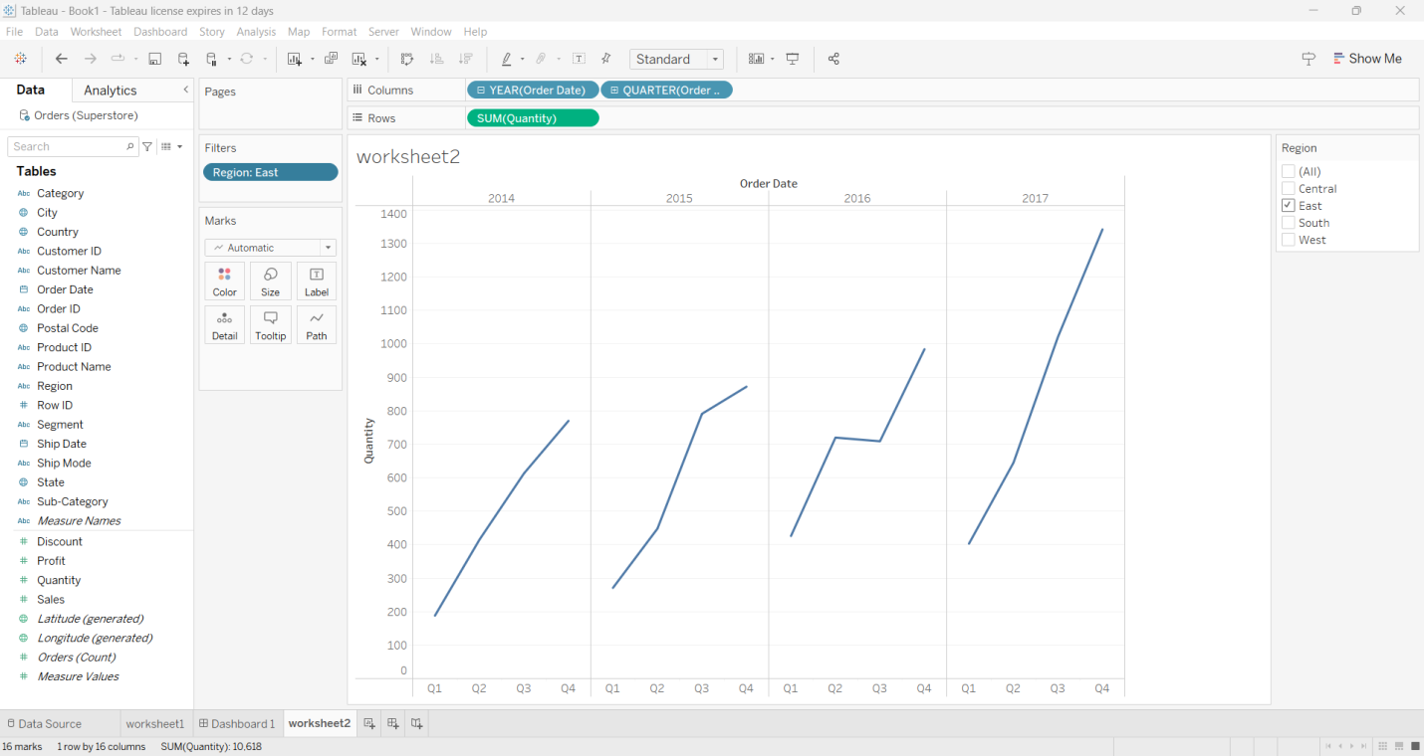

Above we can see the graph is in east region. We can observe quantity in each quarter of a single year.

**Adding Worksheet 2 to Dashboard**

At the bottom of the workbook, click the New Dashboard icon: From the Sheets list at left, drag views to your dashboard at right. To replace a sheet, select it in the dashboard at right.

From the Objects section at lower left, drag a Vertical or Horizontal layout container to the dashboard. Now drag each sheet to the layout container, identified by the dark blue outline.

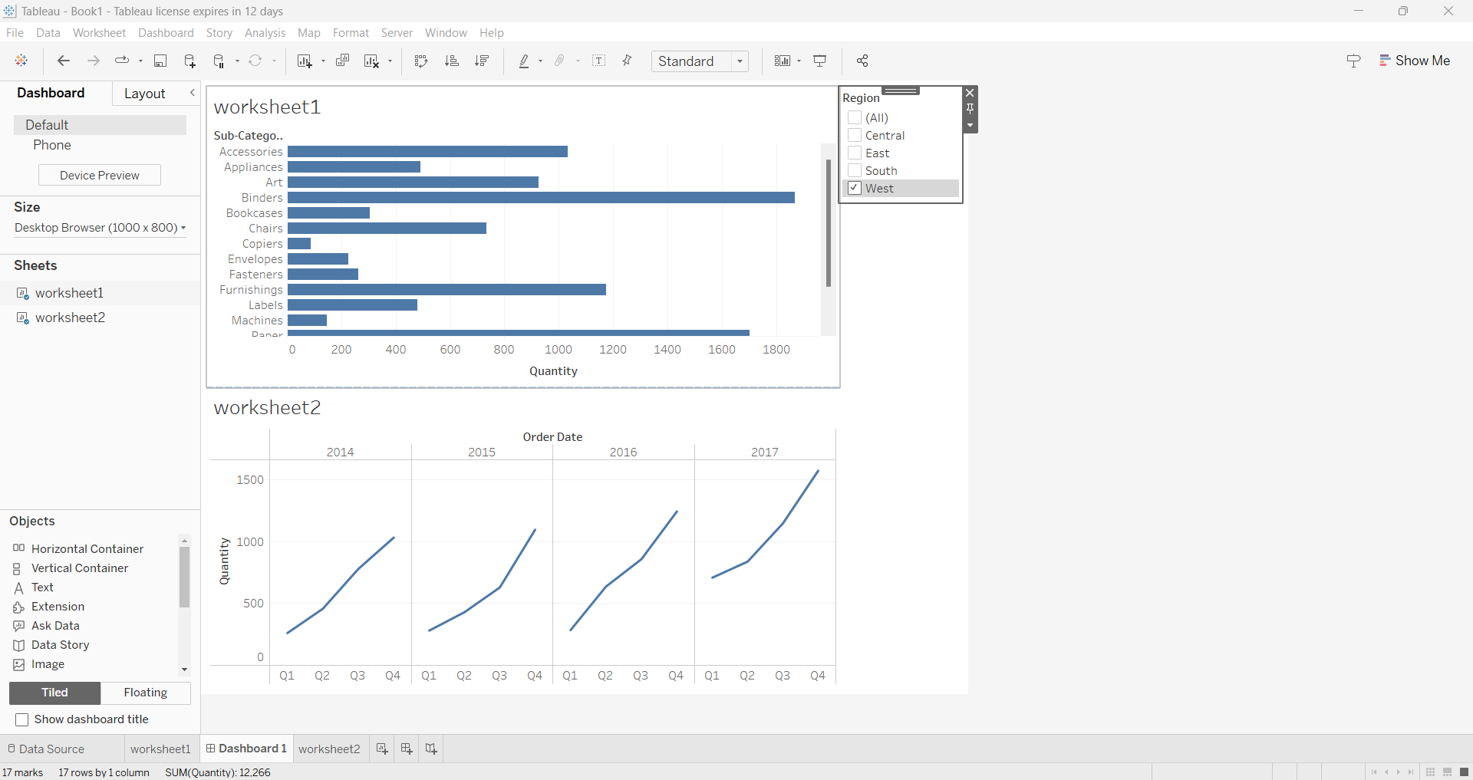

**Step 5:-** Click on dashboard and drag workSheet2 from left side and put in dashboard, so that both worksheets 1 and 2 are interlinked with each other, any change in single selection brings changes in both sheets.

To interlink both worksheets, we need to go back to the worksheet 1 by clicking on it, and then click the filter and Choose “Apply to worksheet” from that choose “All using this Data Sources”. The two worksheets on the dashboard will be interactive now while changing the different region from the filters.

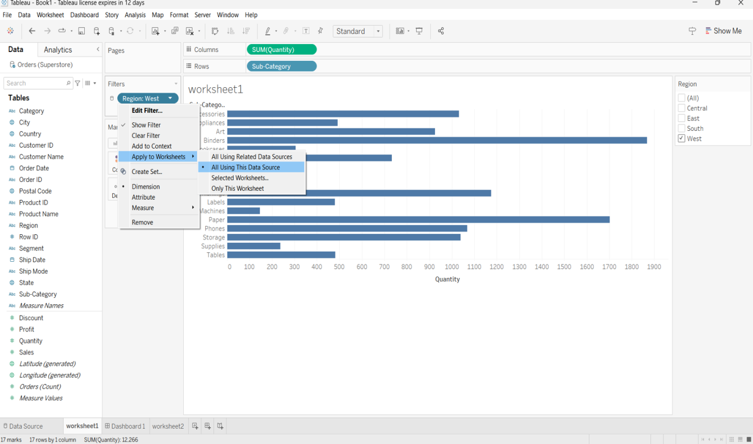

Again, click on Dashboard, now two worksheets are interactive with each other. If we change the filter both the worksheets will get varied.

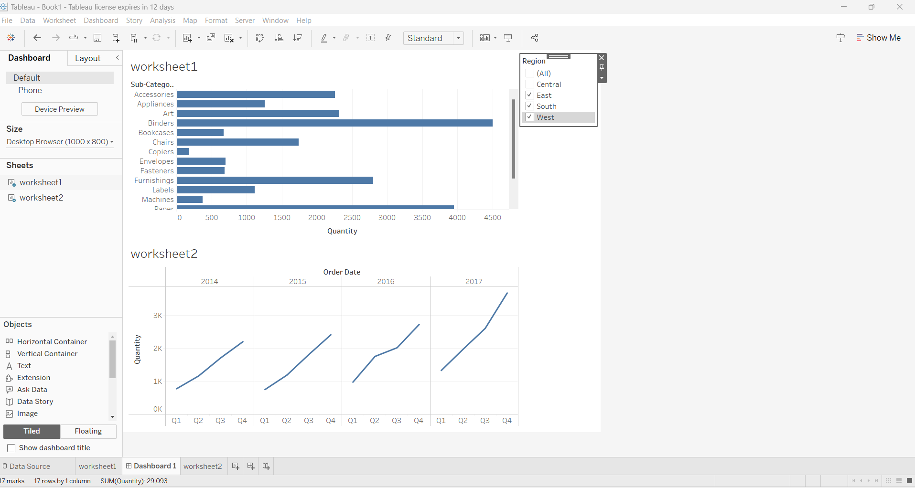

In above, the selected filters are east, south and west regions. For instance, here the Binders has quantity around 4500.When I have changed region to only west the Binders has quantity around 1850.

**Analysis Of Quantity :**

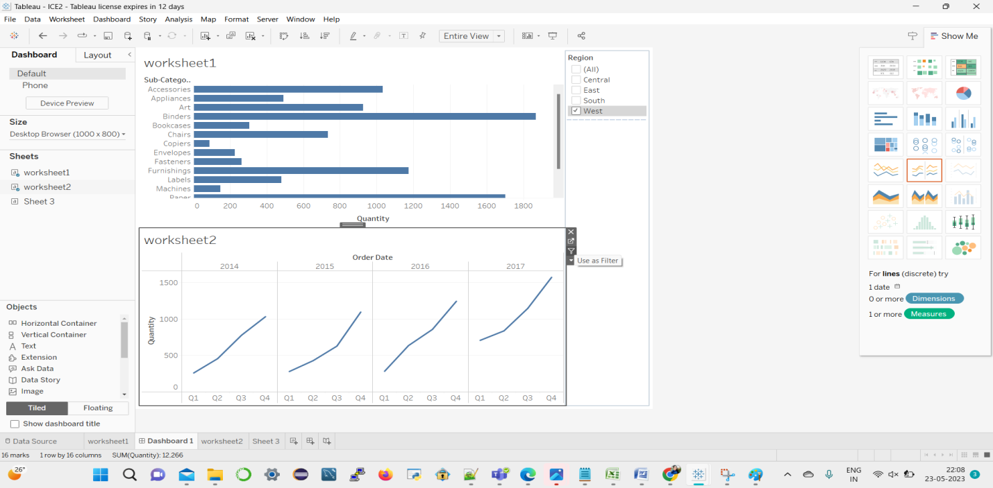

**Step 6**:- Here, click on worksheet 2 and click on “use as filter” symbol. Choose any one spike in the timeline on the worksheet 2.

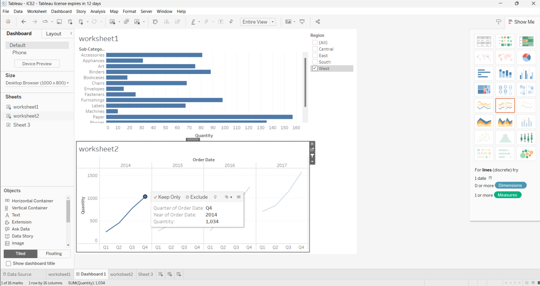

When we place cursor on the spike of worksheet 2, we can see in Quarter of order date Q4 in year 2014 has quantity around 1,034. In worksheet 1, Sub-category “Labels” has quantity around 71.

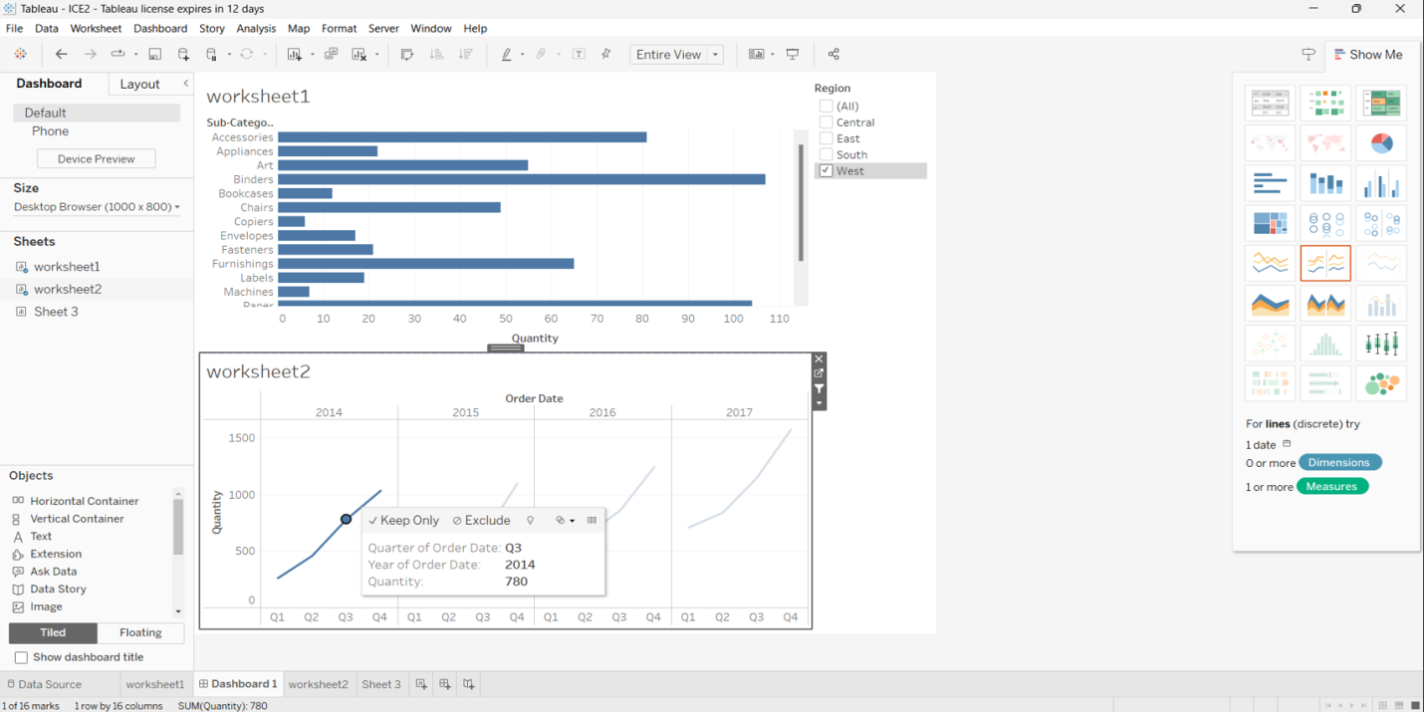

Above, we can see in Quarter of order date Q3 in year 2014 has quantity around 780.When the quarter of order date is changing parallel worksheet 1 is also getting varied. For instance, in worksheet 1,sub-category “Labels” has quantity around 20.

***Observation***:

* In the worksheet 2 we used variables such as Quantity in rows, Order date in column and Region in filter so that shows the Quantity in that entire year of that selected region.
* As per task we need to visualize Quantity in 4 quarters in a single year so that we can see clear quantity in each quarter of a single year.

**Question 2( 50%):**

**Follow the Tutorial 2 and complete the task by using interactivity between the worksheets.**

1) Click on add worksheet as shown in the tutorial. Click on “Profit” add to the rows. Then add “Ship date” to the columns.

2) Select the Ship date to be in quarters(Q1,Q2,Q3,Q4).

3) Add the 2 worksheets on the same dashboard to show interactivity.

4) Click on Q2 in worksheet 2 and explain the changes in Worksheet 1.

5) Explain your understanding of the task and provide analysis of the interactivity of the visualizations.

**Tutorial 3**

**Step 1**:- Click on new worksheet and name it as work sheet 3. Drag the Region from the left and place it on the row field and place Latitude to the row field and Longitude to the column field and then drag state from left side and add it to the color marks and select sales from the left side and add it to the detail.

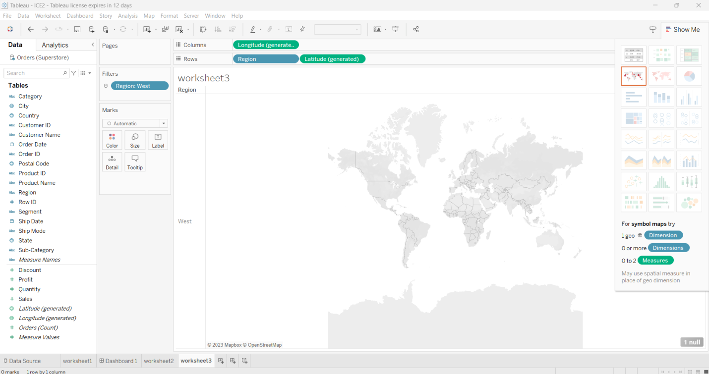

**Step 2:-** Map based Data Visualization

Click on “Region” and “latitude” and drop in rows. Click on “Longitude” and drop in Columns and add state to colors.

Add region to filters as shown in the below fig.

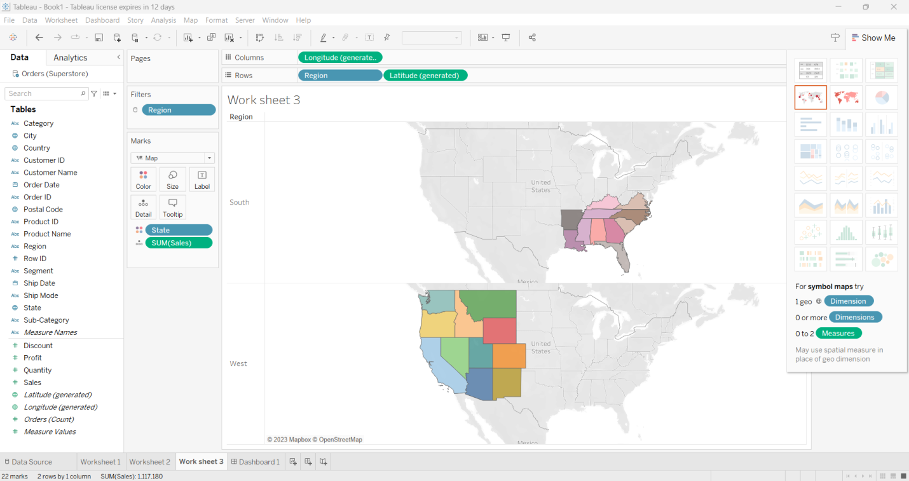

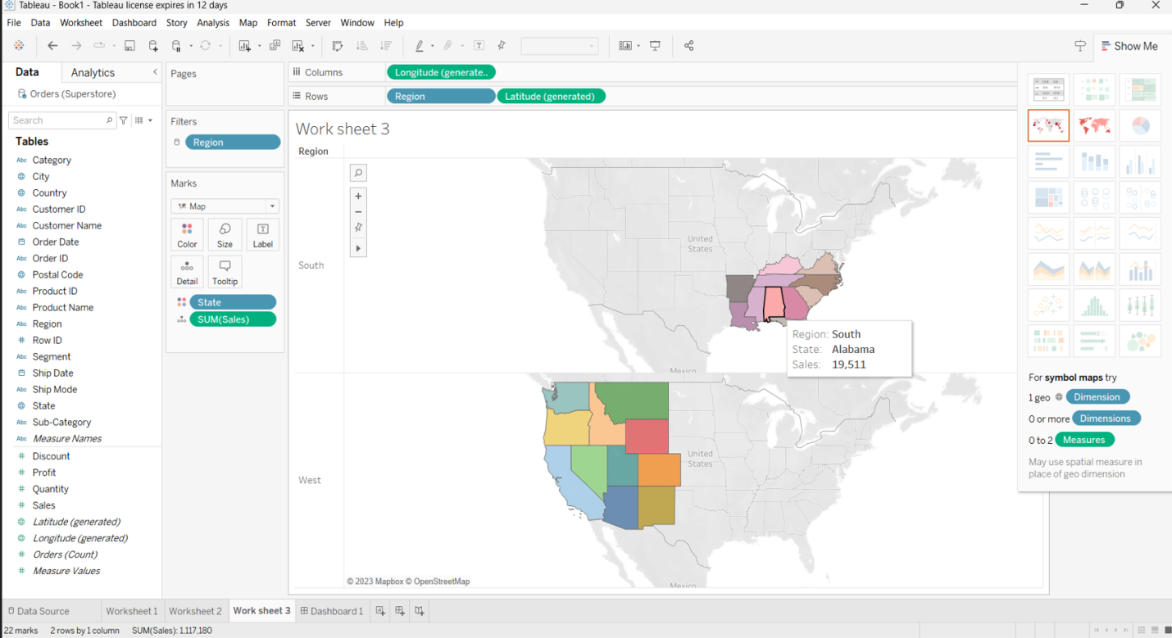

When we place cursor on the map, we get sales of a particular state .

Above, we can see Alabama State has sales 19,511 which is in south region

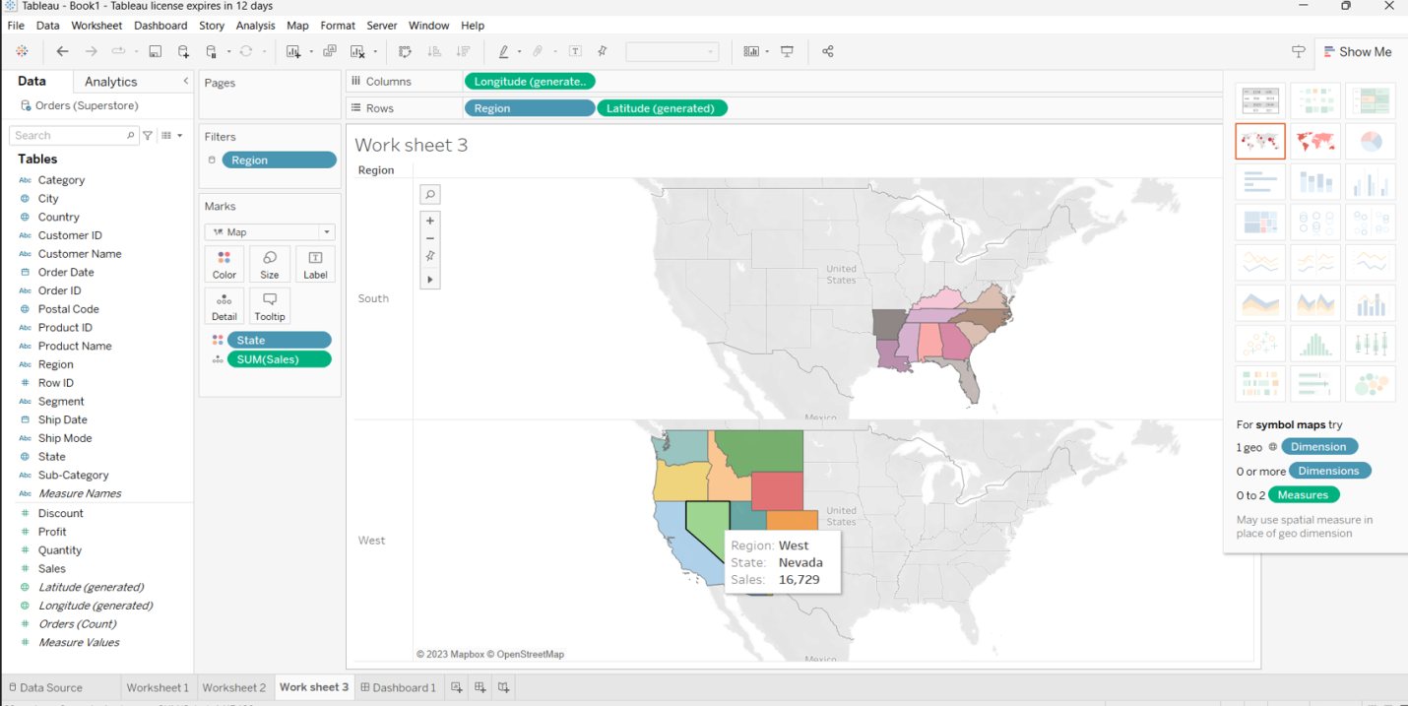

Above, we can see Nevada State has sales 16,729 which is in west region.

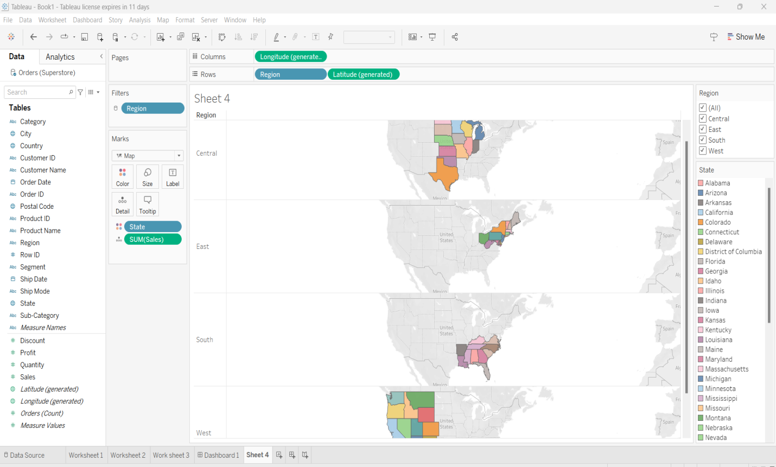

Above graph is the map-based visualization of all four regions .Here we have selected all the regions.

***Observation*:-**

* We create a map in Tableau because we can understand the trends or patterns in your data and have a spatial query.
* In map visualization we can clearly see total sales in each particular state based on our selection of region.
* Using of colors in map visualization that helps us to easily understand the amount of sales produced by each state.
* In above, we have selected two regions south and west. Each state is differentiated with different colors.

**Question 3 (30%):-**

Follow Tutorial 3 and complete the below task.

1) Add “Longitude” on columns and drag “region” and “Latitude” on rows. Drag “State” on color and Profits on detail and show me the profits of states across United states.

2) Provide the screenshot which shows me the “Profit” in Central and Southern part of the United States.

3) What are the Profits in Oklahoma and Texas?

4) What happens if you don’t add filters to the region in the above?

5) Can you change the colors of a particular state to your desired colors?